
Practical Activity 2: DHCP Configuration and Web Server Troubleshooting
Scenario Overview
Your company, Future Network Specialists (FNS), has been contracted by a client, Phetogo Networks, to resolve a critical internal networking issue.
Phetogo Networks is a small technology consulting firm that recently deployed a new internal web server to host:
- Company announcements
- Internal documentation
- IT support portal
However, employees are unable to access the company website from their workstations. When they attempt to open the webpage in a browser, the page does not load.
Management suspects a configuration problem within the internal network. You and your technical team have been assigned to investigate and resolve the issue.

Network Description
The current network design includes:
- 1 Router
- 1 Switch
- Multiple PCs (client machines)
- 1 Web Server
Intended Configuration
- PCs must obtain IP addresses automatically using DHCP
- The Server must be configured with a static IP address
- The Server hosts a webpage accessible via browser
- All devices are connected through a switch in a single LAN

QUESTIONS
Configurations | Answers
1. What is the MAC address of Server0? | Type MAC address: 00D0.BC7E.0479
2. What is the MAC address of the Switch port connected to the FastEthernet0/0 of the Router? | Type MAC address: 00D0.BC21.9B25
3. Assign the IP address <192.168.1.254> to Server0 | Configured
4. Configure PC0 to use DHCP addressing | Configured
5. Successfully ping Server0 from PC0 <ping Server0 IP Address> | Attach screenshot of the ping test  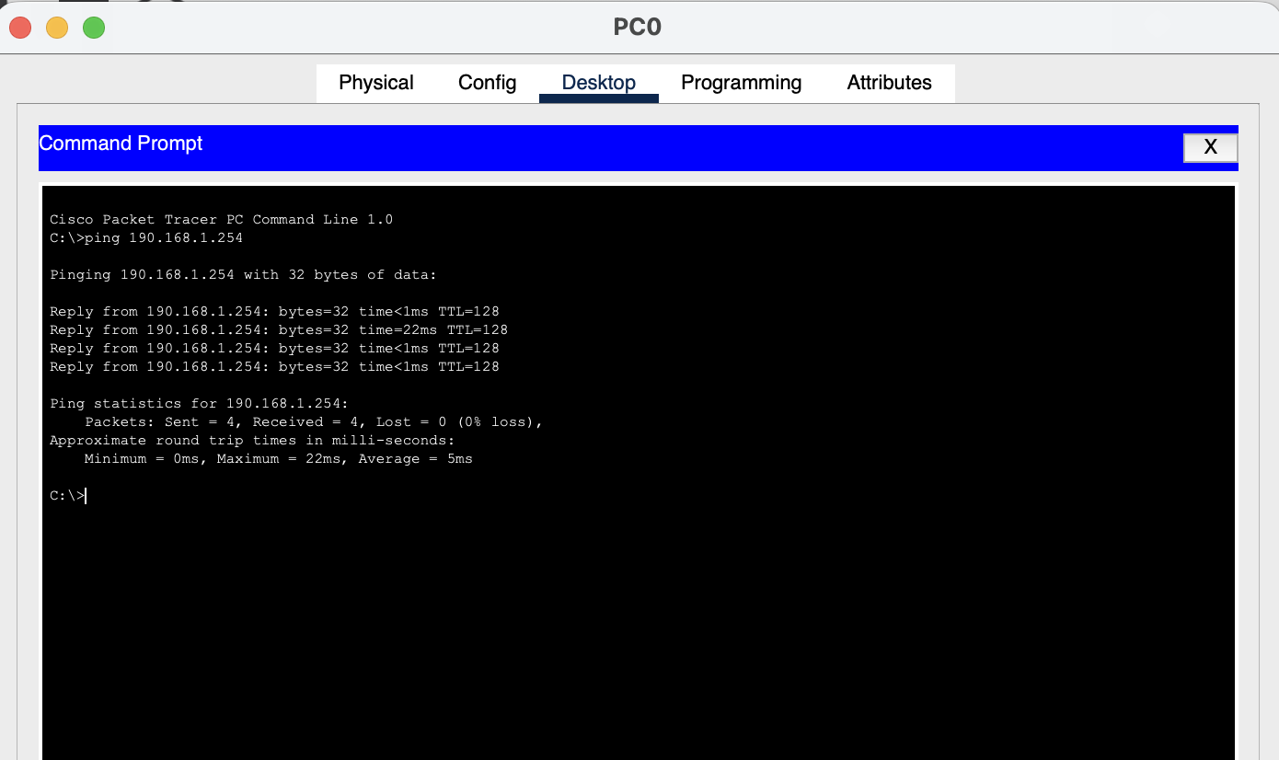
6. Access this URL from PC0 http://192.168.1.254. | Attach a screenshot of the webpage <It should display your assigned name>  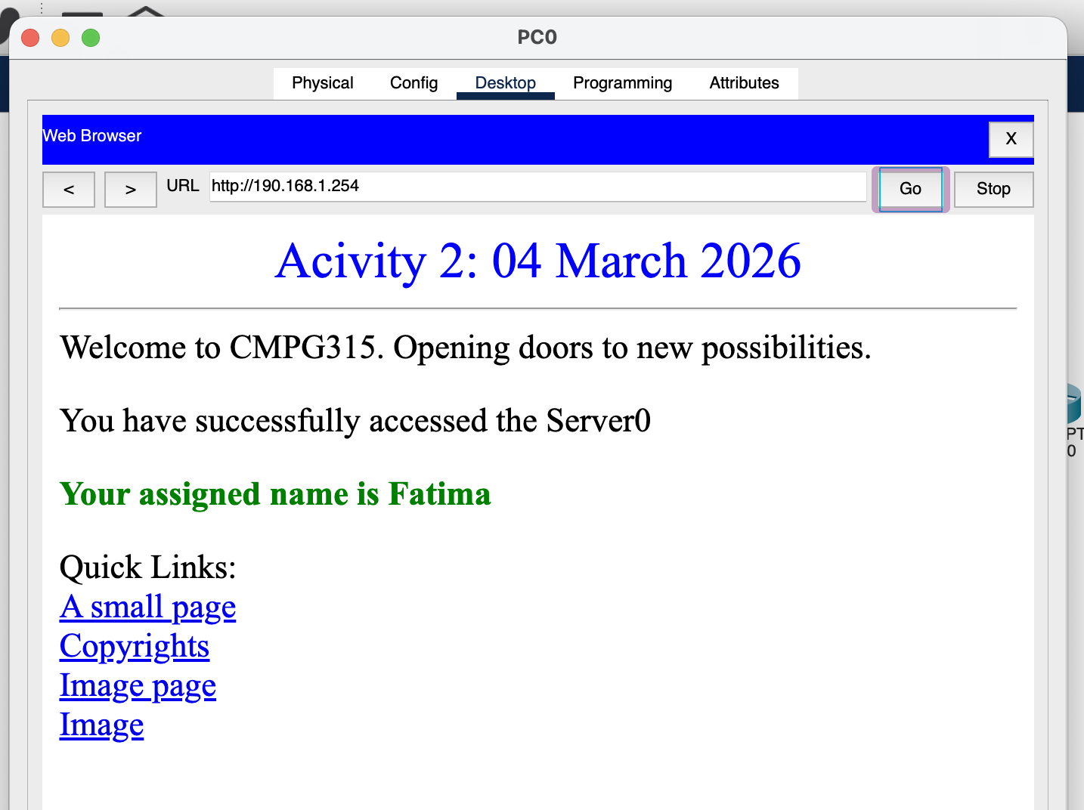

N.B
Upload this file on Efundi

